MASS TIMES

Sunday: English 9AM, Español 11:30AM
Monday: NO MASS
Tuesday: English 12PM
Wednesday: English 6PM
Thursday: English 12PM, Adoration 6PM, Español 7PM
Friday: Adoration 11AM, English 12PM
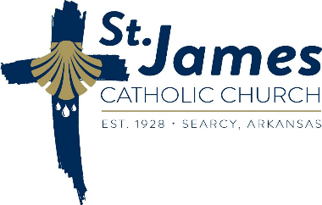
Saturday: English (St Richard) 4PM, English (St. James) 5:3oPM

